Programming in C

**Drishya Neupane** **Ms.Rabina Chaudhary**

BE Software Programming in C

Roll no: 201648 Software Department

**Practical No: 2**

**Title:** TO LEARN THE CONDITIONAL STATEMENTS

**Objective:**

1. Understanding the conditional statements.
2. Understanding proper use and utilization of if, if-else, nested if-else.
3. Using conditional statements to solve conditional problems

**Theory:**

* Conditional Statements/Decision Control Instructions: **Conditional Statements** are used to make decisions based on the conditions. They execute sequentially when there is no condition around the statements. i.e. if, if-else, nested if-else, nested else-if
* if statement: If statement is the most basic conditional statement. It is always used with a condition and evaluates statements to either true or false. It is used as
  + - If (condition is true)

execute this statement;

* if-else statement: The if statement does nothing when the condition is false. In such case, the if-else statement is used. It is used as
  + - If (condition is true)

execute this statement;

else

execute this statement;

* Nested if-else: If multiple conditions are required then nested if-else is used. So using if-else construct within if/or statement is called nesting. It is used as
  + - If (condition is true)

execute this statement;

else

[ if(condition is true)

execute this statement

else

Example:

#include<stdio.h>

int main() {

int a;

printf(“Enter a number”);

scanf(“%d”,&a);

if (a==0)

printf(“You just typed the number 0”);

else

{ if (a > 0)

printf(“You just typed a number greater than 0”);

else

printf(“You just typed a number less than 0”);

}

printf(“

return 0;

}

(Here nested if else is used to state w condition whether the number is 0, less than 0 or greater than it)

OUTPUT

Enter a number: -1

You just typed a number less than 0

**Practical:**

1. **What will be the value of A and B on each line? A=10, B= 5; A=++A + ++A; B=A-- - --B; Also explain the operations**.

Algorithm:

Step 1: Start

Step 2: Declare variable A, B

Step 3: Input A = 10, B = 5

Step 4: Perform A = ++A + ++A & B = A-- - --B

Step 5: Display the information

Step 6: Stop

Flowchart:

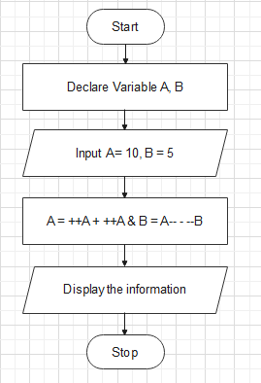

Program:

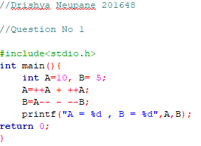

Output:

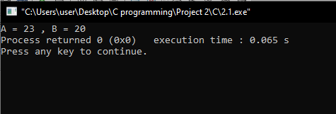

Here, the final value of A is displayed as 23 and B is displayed as 20

We know A++ will increment the value of A and return it to A

Where ++A will increment the value of A and replace its new value

i.e ++A = 11 (New value of A= 11) & A++ = 11+1 = 12

Then, A = 12 + 11 = 23

Similarly for B, the value becomes 24 by following the rule of increment for A

Then, for B, A = 13 + 12 = 25 (i.e. new value of A = 12)

So, A-- = 24 & --B = 4

i.e A-- - --B = 24 – 4 = 20

1. **Write a program to find out whether the entered number is odd or even using conditional operator**.

Algorithm:

Step 1: Start

Step 2: Declare variable X

Step 3: Display "Input a number"

Step 4: Enter the number

Step 5: Check if X\2 = 0

Step 5.1: If Step 5 is true

Step 5.2: Display the number is even

Step 5.1: If Step 5 is false

Step 5.2: Display the number is odd

Step 6: Stop

Flowchart:

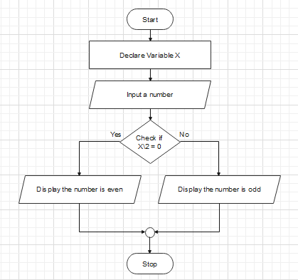

Program:

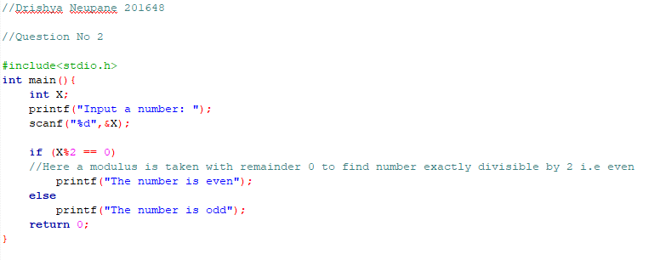

Output:

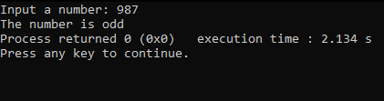

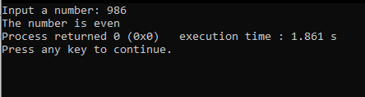

1. **Write a program to read the value of two variables, compute sum, difference and product**

Algorithm:

Step 1: Start

Step 2: Declare variable a,b,c

Step 3: Display "Input the value of a, b, c"

Step 4: Input the values of a, b, c

Step 5: Check a > b

Step 5.1: If Step 5 is true

Step 5.1.1: Check if a > c

Step 5.1.1.1: If Step 5.1.1 is true

Step 5.1.1.1.1: Display a is greatest

Step 5.1.1.2: If Step 5.1.1 is false

Step 5.1.1.2.1: Display c is greatest

Step 5.2: If Step 5 is false

Step 5.2.1: Check if b > c

Step 5.1.1.1: If Step 5.1.1 is true

Step 5.1.1.1.1: Display b is greatest

Step 5.1.1.2: If Step 5.1.1 is false

Step 5.1.1.2.1: Display c is greatest

Step 6: Stop

Flowchart:

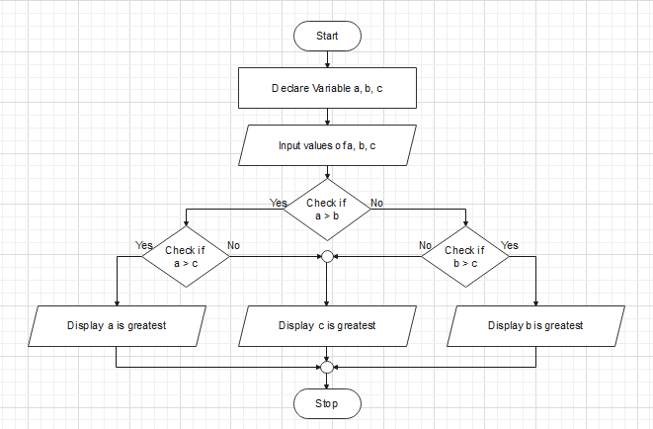

Program:

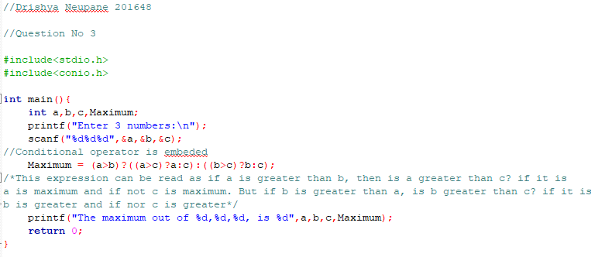

Output:

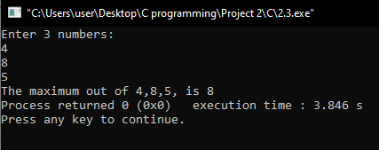

1. **Write a program to find out the real and equal roots of a quadratic equation using conditional operator**.

Algorithm:

Step 1: Start

Step 2: Declare variable a, b, c

Step 3: Display "Input the coefficient of x^2, x and constant of the quadratic equation"

Step 4: Input coefficient of x^2, x and constant (i.e. a, b, c)

Step 5: Check if (b^2)-(4*a*c)>0

Step 5.1: If Step 5 is true

Step 5.1.1: Check if (b^2)-(4*a*c) ==0

Step 5.1.1.1: If Step 5.1.1 is true

Step 5.1.1.1.1: The roots are equal, Alpha=Beta=-b/(2*a)

Step 5.1.1.1.2: Display Alpha, Beta

Step 5.1.1.2: If Step 5.1.1 is false

Step 5.1.1.2.1: Alpha = (-b - ((b^2) - 4*a*c)^0.5)) / (2*a)

Beta = (-b + ((b^2) - 4*a*c)^0.5)) / (2*a)

Step 5.1.1.2.2: Display Alpha, Beta

Step 5.2: If Step 5 is false

Step 5.2.1: Display the roots are imaginary

Step 6: Stop

Flowchart:

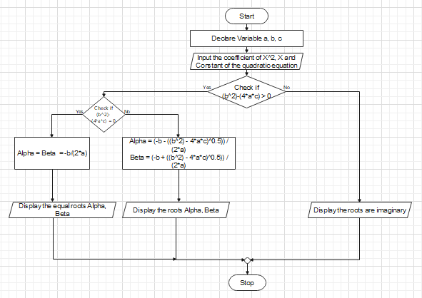

Program: 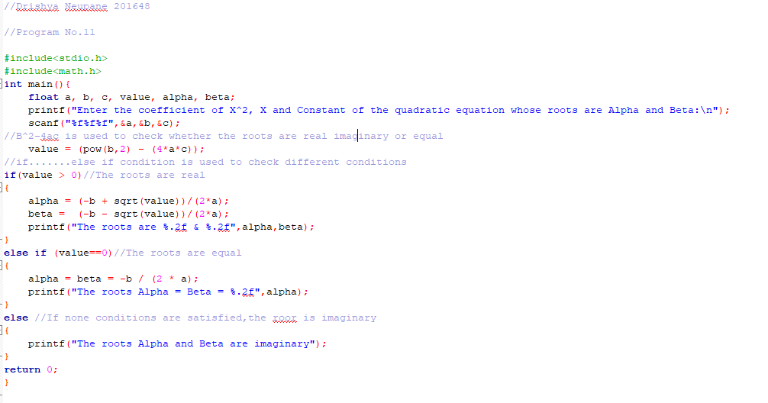

Output:

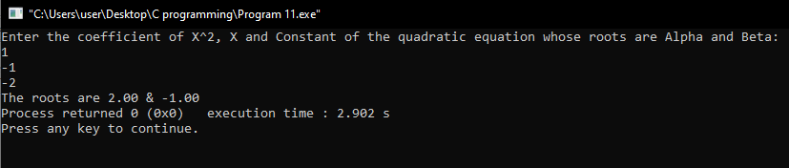

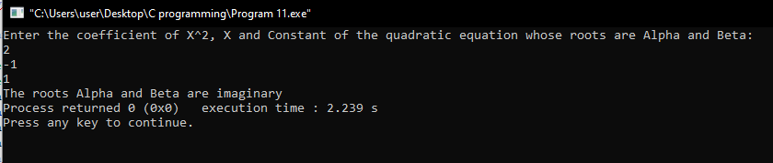

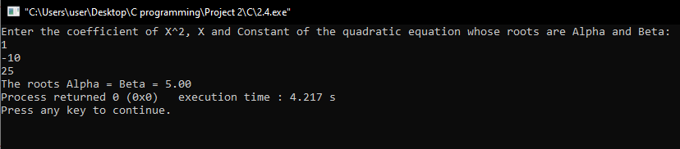

1. .**Write a program to illustrate the modulus operator in which second is given as an input and the program converts it to hours, minutes and seconds**.

Algorithm:

Step 1: Start

Step 2: Declare variable x,hour,minute,second

Step 3: Display "Input the time period to be converted"

Step 4: Input the time in second

Step 5: hour = x/1000, minute = hour%1000, second = (x%3600)%60

Step 6: Display hour, minute, second

Step 7: Stop

Flowchart:

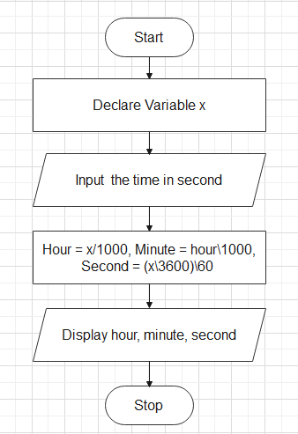

Program:

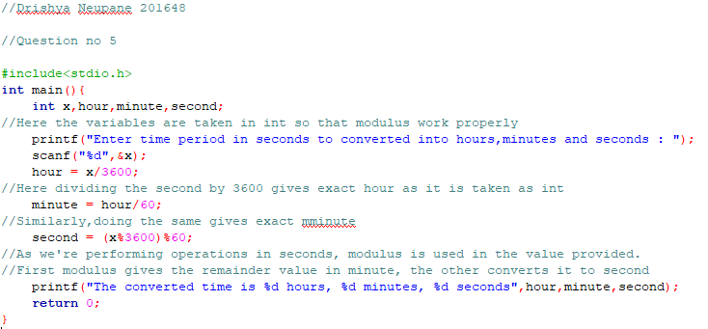

Output:

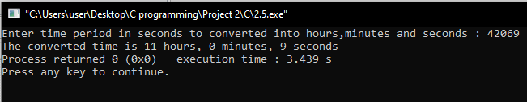

1. **Write a program that asks for your height in feet and inches and your weight in kilograms (use three variables to store the information). Convert your height in feet and inches to your height in inches. Then convert your height in inches to height in meter by multiplying it by 0.0254. Now divide your weight by square of your height in meter and finally assign the output to variable ratio. Also display all the information**.

Algorithm:

Step 1: Start

Step 2: Declare variable weight, height1, height2

Step 3: Display "Enter your height in feet and inches and your weight in kilogram"

Step 4: Enter your height in feet (as height1) and inches as (height 2) and your weight in kilogram

Step 5: inch = (height1*12) + height2, meter = inch*0.0254, ratio = weight/pow(meter,2)

Step 6: Display inch, meter & ratio

Step 7: Stop

Flowchart:

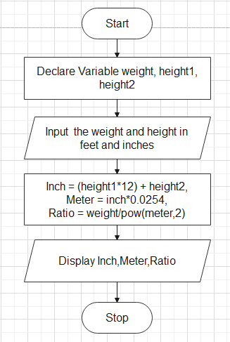

Program:

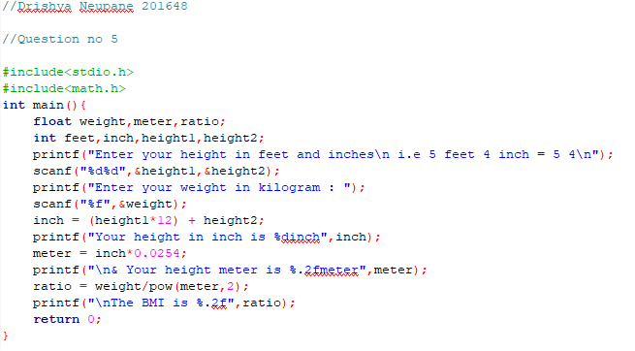

Output:

